**Project Title**

**Edu Tutor – AI Powered Learning Assistant**

**Project Documentation**

**Team Members**

* Team Leader: [Jay Kumar. P]
* Team member: [Gokulakannan. N]
* Team member: [Gnanaprakash. P]
* Team member: [Jayaraman. K]

**1. Introduction**

**1.1 Background**

Education today is rapidly evolving. Traditional classroom-based instruction, while still central to learning, is increasingly supplemented with online content, e-learning platforms, and digital tutoring systems. However, despite technological advances, students often struggle to receive **personalized guidance**, timely **academic support**, and **effective feedback**. Teachers face the challenge of scaling individual attention to a large group of learners.

Edu Tutor was conceived to address this gap. It is an **AI-powered smart educational assistant** that uses advanced natural language models and predictive analytics to create a **personalized learning experience** for every student, while simultaneously providing tools for teachers and institutions to optimize teaching outcomes.

**1.2 Vision & Mission**

* **Vision:** To democratize high-quality education by making personalized tutoring accessible to every learner.
* **Big Picture Goal:** Edu Tutor aims to make **high-quality, personalized learning available to everyone**, no matter where they live or what resources they have.
* **What This Means:**
  + Every student, whether in a small town or a big city, can access instant, AI-powered tutoring and learning materials.
  + Learning becomes **tailored to the individual**, not “one-size-fits-all.”
  + Teachers get **powerful tools** to improve their teaching and save time.
* **long-Term Impact:** Edu Tutor envisions a future where AI acts as a **friendly assistant** to both students and teachers — boosting confidence, improving results, and helping institutions make better decisions.
* **Mission:** To leverage AI and data-driven insights to enhance student learning outcomes, support educators in course planning and evaluation, and build a comprehensive digital learning ecosystem.
* **Big Picture Goal:** Edu Tutor aims to make **high-quality, personalized learning available to everyone**, no matter where they live or what resources they have.
* **What This Means:**
  + Every student, whether in a small town or a big city, can access instant, AI-powered tutoring and learning materials.
  + Learning becomes **tailored to the individual**, not “one-size-fits-all.”
  + Teachers get **powerful tools** to improve their teaching and save time.
* **Long-Term Impact:** Edu Tutor envisions a future where AI acts as a **friendly assistant** to both students and teachers — boosting confidence, improving results, and helping institutions make better decisions.

**Edu Tutor Mission**

Edu Tutor’s mission explains **how it will achieve this vision**. It focuses on three main areas:

1. **Personalizing Learning**
   * Use AI to analyse each student’s progress.
   * Create custom study plans and recommend the best resources.
   * Provide real-time tutoring and quick answers to questions.
2. **Empowering Educators**
   * Automate repetitive tasks like quiz creation, grading assistance, and content summarization.
   * Provide clear analytics dashboards so teachers can identify weak areas quickly.
3. **Building a Scalable and Secure Platform**
   * Design Edu Tutor to work for small classes or entire universities.
   * Use secure, cloud-ready architecture to protect student data.
   * Integrate easily with existing Learning Management Systems (LMS) or school software.

**1.3 Objectives**

**1. Personalized Learning for Students**

* **Real-Time Tutoring:** Provide instant, AI-driven answers to students’ questions across multiple subjects, reducing waiting time for help.
* **Adaptive Study Plans:** Automatically adjust study paths based on individual strengths, weaknesses, and pace of learning.
* **Content Simplification:**Summarize large textbooks, lecture notes, or research papers into easily digestible notes, flashcards, or key points**.**
* **Performance Tracking:**Offer dashboards showing grades, quiz results, and progress over time so students can see exactly where they stand**.**

**2. Efficiency Tools for Teachers**

* **Automated Quiz & Assignment Generator:**Generate multiple-choice, short-answer, and case-study questions from uploaded material to save time.
* **Lesson Planning Assistance:**Provide teachers with summarized content and topic breakdowns for easier lecture preparation.
* **Student Progress Insights:**Use predictive analytics to highlight at-risk students and suggest intervention strategies.
* **Feedback Collection:**Gather feedback from students on quizzes or lessons to continually improve teaching material.

**3. Comprehensive Data & Analytics for Institutions**

* Performance Analytics Dashboard:  
  Show trends and KPIs (Key Performance Indicators) at the class or institution level to help administrators make decisions.
* Curriculum Effectiveness Measurement:  
  Analyse which topics are hardest or easiest across cohorts to improve teaching strategies.
* Resource Utilization:  
  Monitor which resources students use the most to inform future investments or improvements.

**4. Multimodal & Inclusive Learning**

* **Support for Multiple Input Types:**Allow users to upload PDFs, audio lectures, or text notes, and automatically convert them into searchable, summarized content.
* **Accessibility & Inclusivity:**Design the interface and features to work for all students, including those with disabilities or limited internet bandwidth**.**

**5. Security & Privacy**

* **Role-Based Access:**Protect sensitive student data with separate permissions for students, teachers, and admins.
* **Data Encryption:**Ensure all uploaded files, quiz results, and analytics are encrypted both in transit and at rest.

**6. Integration & Scalability**

* **LMS Integration:**Seamlessly connect Edu Tutor with existing systems like Moodle or Google Classroom.
* **Scalable Architecture:**Design the backend to support thousands of concurrent users without slowdowns.
* **Cloud & On-Premise Options:**Offer flexibility for institutions with different IT policies or privacy needs.

**7. Continuous Improvement**

* **Feedback Loops:**Collect and analyse feedback from students and teachers to improve AI models and content quality**.**
* **Regular Updates:**Add new features, improve algorithms, and maintain security patches to keep Edu Tutor up-to-date with technological trends.

**8. Long-Term Objectives**

* **Multilingual Support:**Offer tutoring, quizzes, and dashboards in multiple languages.
* **Voice Interaction:**Add speech-to-text and text-to-speech features to make the tutoring experience more natural.
* **AI-Coach Mode:**Simulate interactive tutoring sessions with varying levels of difficulty to challenge students dynamically**.**

**2. Project Overview**

**2.1 Purpose**

Edu Tutor is designed as a comprehensive **AI-powered digital learning companion**. It serves three key user groups:

1. **Students:** Provides instant answers, curated study notes, quizzes, and personalized recommendations.
2. **Teachers:** Automates quiz creation, assignment generation, and gives performance insights.
3. **Institutions:** Centralizes data analytics and supports scalable education delivery.

By combining **natural language interaction**, **predictive analytics**, and **interactive dashboards**, Edu Tutor bridges the gap between students, teachers, and educational content.

**2.2 Key Benefits**

**1. Personalized Learning Experience**

* **Benefit:** Each student receives a learning path tailored to their abilities, pace, and preferences.
* **How it Works:** Edu Tutor uses AI to analyze quiz results, time spent on topics, **and past performance to recommend the next best steps.**
* **Why it Matters:** Students learn more efficiently, retain more information, and feel more confident because content is neither too hard nor too easy.

**2. Instant Tutoring & Support**

* **Benefit:** Students get real-time answers to questions, similar to having a personal tutor available 24/7.-study habits.

**3. Automated Content Creation for Teachers**

* **Benefit:** Teachers save hours preparing quizzes, assignments, and summaries.
* **How it Works:** Upload a chapter outline, and Edu Tutor automatically generates multiple-choice questions, short answers, and even model solutions.
* **Why it Matters**: Allows educators to focus on teaching quality, feedback, and creative tasks instead of repetitive work.

**4. Comprehensive Performance Analytics**

* **Benefit:** Real-time dashboards show student or class performance trends.
* **How it Works:** Tracks quiz scores, time spent per topic, and improvement over time; displays data visually.
* **Why it Matters:** Teachers can identify at-risk students early and offer timely interventions.

**5. Resource Recommendation Engine**

* **Benefit:** Suggests the best supplementary resources (videos, articles, practice exercises) tailored to student needs.
* **Example:** If a student is weak in “Trigonometry,” Edu Tutor recommends a video tutorial and practice sheets.
* **Why it Matters**: Expands learning beyond textbooks and keeps students engaged.

**6. Multimodal Input & Flexibility**

* **Benefit:** Users can upload PDFs, audio files, or text, and Edu Tutor processes all of them.
* **Example:** Teacher uploads a recorded lecture — Edu Tutor transcribes it and generates key notes and quizzes.
* **Why it Matters**: Makes the platform inclusive and convenient for different learning styles.

**7. Secure and Scalable Platform**

* Benefit: Works for small classes or large universities with equal reliability.
* Security Measures: Role-based access, encrypted storage, secure APIs.
* Why it Matters: Protects student data and ensures smooth performance even with thousands of users simultaneously**.**

**8. Integration with Existing Systems**

* **Benefit:** Seamlessly plugs into Learning Management Systems (LMS) like Moodle, Google Classroom, or Canvas.
* **How it Works:** Edu Tutor APIs allow automatic quiz import/export, student roster syncing, and gradebook updates**.**
* **Why it Matters:** Institutions don’t have to replace existing software — Edu Tutor enhances it.

**9. Cost & Time Efficiency**

* **Benefit:** Reduces the cost of hiring multiple tutors or creating custom content manually.
* **How it Works:** Automation and AI handle repetitive tasks quickly.
* **Why it Matters:** Saves time for teachers and administrators, making education more affordable and efficient.

**1. Reduced Content Creation Costs**

* **Traditional Way:** Teachers spend hours creating quizzes, assignments, and summaries manually.
* **With Edu Tutor**: AI automatically generates quizzes, assignments, and summaries from uploaded content in seconds**.**
* **Benefit:** Saves salaries, overtime, and effort spent on repetitive work.

**2. Lower Need for Additional Tutors**

* **Traditional Way:** Schools and colleges often hire extra tutors for remedial teaching.
* **With Edu Tutor:** Students get 24/7 AI tutoring support to clarify doubts instantly.
* **Benefit**: Reduces the need for external tuition, cutting costs for institutions and parents**.**

**3. Time Savings for Teachers**

* **Automated Grading Assistance:** Quizzes and assignments can be auto-graded or pre-checked by the system.
* **Faster Lesson Planning:** Summaries and teaching outlines are generated automatically from learning material.
* **Benefit:** Teachers reclaim time for interactive teaching, mentoring, and personalized student attention.

**4. Scalable Infrastructure**

* **Cloud-Ready Architecture:** Can scale to handle thousands of students without needing major hardware investments**.**
* **One-Time Setup:** After initial setup, running costs are mostly limited to cloud fees and API usage.
* **Benefit:** Pay only for what you use, instead of maintaining expensive on-site servers.

**5. Reduced Administrative Overhead**

* **Automated Analytics:** Performance dashboards reduce manual data entry and reporting.
* **Centralized Management:** Role-based access and dashboards streamline user management.
* **Benefit:** Admin staff spend less time consolidating and analysing student performance data.

**6. Quick Onboarding and Training**

* **Easy to Learn Interface:** Teachers and students can start using the system with minimal training.
* **Reduced Support Calls:** Simple UI and in-app guidance reduce time spent on support or troubleshooting.
* **Benefit:** Faster adoption means quicker ROI (Return on Investment**).**

**7. Long-Term Savings**

* **Continuous Updates:** Edu Tutor’s improvements and AI model upgrades reduce the cost of buying new software frequently**.**
* **Data-Driven Decision Making:** Schools can optimize resource allocation (books, tutoring hours) based on analytics.

**10. Continuous Improvement through Feedback**

* **Benefit:** Edu Tutor learns and improves from student and teacher feedback.
* **How it Works**: Feedback forms and ratings are collected and analyzed to refine content and recommendations.
* **Why it Matters**: Keeps the platform up-to-date, relevant, and aligned with user needs.

**11. Accessibility & Inclusivity**

* **Benefit:** Designed with WCAG-compliant accessibility features.
* **Examples**: Adjustable text size, colour-blind friendly charts, keyboard navigation, and text-to-speech options.
* **Why it Matters**: Ensures students with disabilities or different needs are not left behind.

**12. Future-Proof Learning Companion**

* **Benefit:** Edu Tutor evolves with new AI models, multilingual support, and voice interaction.
* **Why it Matters:** Institutions investing in Edu Tutor today can rely on it being relevant and powerful tomorrow.

**2.3 Features (Expanded)**

**1. Conversational Interface**

* *What it is:* An AI-powered chat interface.
* *How it helps:* Students ask questions, receive instant answers with explanations; teachers can request summaries or resource suggestions.
* *Benefit:* Reduces learning latency, enhances engagement.

**2. Personalized Learning Paths**

* *What it is:* AI generates individualized study plans based on performance metrics.
* *How it helps:* Tracks learning pace and adjusts topics dynamically.
* *Benefit:* Improves retention and outcomes.

**3. Quiz and Assignment Generator**

* *What it is:* An automated quiz/assignment creation tool.
* *How it helps:* Teachers upload topics or chapters; Edu Tutor generates MCQs, short answers, and case studies.
* *Benefit:* Saves time, ensures varied assessments.

**4. Content Summarization**

* *What it is:* Converts lengthy documents into short, actionable notes.
* *How it helps:* Students can quickly revise large textbooks; teachers can extract core ideas for lectures.
* *Benefit:* Speeds up comprehension and revision.

**5. Performance Analytics Dashboard**

* *What it is:* Real-time dashboards showing student progress.
* *How it helps:* Displays metrics like time spent, topics mastered, quiz scores.
* *Benefit:* Helps educators identify at-risk students early.

**6. Resource Recommendation Engine**

* *What it is:* Suggests learning materials (videos, articles, exercises).
* *How it helps:* Students receive supplementary materials based on weaknesses.
* *Benefit:* Promotes continuous improvement.

**7. Feedback Loop**

* *What it is:* Collects and processes feedback from students/teachers.
* *How it helps:* Improves content quality and AI model performance.
* *Benefit:* Builds a responsive and evolving platform.

**8. Multimodal Input Support**

* *What it is:* Accepts text, PDFs, and audio.
* *How it helps:* Teachers/students upload varied file types; Edu Tutor extracts knowledge.
* *Benefit:* Flexible and inclusive for diverse users.

**9. Streamlit or Gradio UI**

* *What it is:* A clean, user-friendly web interface.
* *How it helps:* Easy navigation via sidebar, tabbed sections, responsive design.
* *Benefit:* Low learning curve even for non-technical users.

**3. Architecture**

* **Frontend (Streamlit):** Interactive dashboards, modular UI, live chat window, upload sections, analytics pages.
* **Backend (FastAPI):** RESTful API for tutoring, content processing, and analytics.
* **LLM Integration:** Connects to GPT/Watsonx models for NLP tasks.
* **Vector Search (Pinecone):** Stores embeddings of uploaded documents for semantic search.
* **ML Modules:** Predict performance, recommend resources, detect anomalies.
* **Database:** Stores user profiles, quiz history, performance logs.
* **Security:** JWT authentication, role-based access control.

**4. Setup Instructions (Expanded)**

We’ll describe:

* System Requirements (Hardware/Software)
* Installation Steps (Detailed commands)
* API Key Management
* Running the application locally vs. cloud deployment
* Troubleshooting tips

**5.Folder Structure (Expanded)**

**Edu-Tutor/**

**│**

**├── backend/ # FastAPI backend service**

**│ ├── app/**

**│ │ ├── __init__.py**

**│ │ ├── main.py # Entry point for FastAPI backend**

**│ │ ├── config.py # Environment settings, API keys, database URLs**

**│ │ ├── models/ # Database models and schemas**

**│ │ │ ├── user.py**

**│ │ │ ├── quiz.py**

**│ │ │ └── analytics.py**

**│ │ ├── routes/ # API endpoint definitions**

**│ │ │ ├── auth.py**

**│ │ │ ├── tutor.py**

**│ │ │ ├── upload.py**

**│ │ │ ├── quiz.py**

**│ │ │ └── analytics.py**

**│ │ ├── services/ # Business logic**

**│ │ │ ├── llm_service.py # Large Language Model interface**

**│ │ │ ├── pinecone_service.py**

**│ │ │ ├── quiz_generator.py**

**│ │ │ └── analytics_service.py**

**│ │ ├── utils/ # Helper functions**

**│ │ │ ├── file_utils.py**

**│ │ │ ├── security.py**

**│ │ │ └── logging.py**

**│ │ └── tests/ # Unit and integration tests**

**│ │ ├── test_auth.py**

**│ │ ├── test_quiz.py**

**│ │ └── test_upload.py**

**│ │**

**│ ├── requirements.txt # Python dependencies**

**│ ├── Dockerfile # Container configuration for backend**

**│ └── README.md**

**│**

**├── frontend/ # Streamlit dashboard / Web UI**

**│ ├── edu_dashboard.py # Main dashboard app**

**│ ├── components/ # Reusable UI components**

**│ │ ├── sidebar.py**

**│ │ ├── charts.py**

**│ │ └── forms.py**

**│ ├── assets/ # Images, CSS, logos**

**│ ├── tests/ # UI tests (Selenium)**

**│ └── requirements.txt # Frontend dependencies**

**│**

**├── data/ # Uploaded content and generated files**

**│ ├── uploads/ # User uploaded PDFs/audio files**

**│ ├── embeddings/ # Vector representations for search**

**│ └── reports/ # Auto-generated quizzes/reports**

**│**

**├── docs/ # Documentation, screenshots, diagrams**

**│ ├── screenshots/**

**│ ├── diagrams/**

**│ └── project_docs/**

**│**

**├── scripts/ # Utility scripts (migrations, maintenance)**

**│ ├── db_migrate.py**

**│ ├── sample_data_loader.py**

**│ └── backup.py**

**│**

**├── .env # Environment variables (not checked into Git)**

**├── .gitignore # Ignore sensitive files in version control**

**└── README.md # Overview of the project**

**6. Running the Application (Expanded)**

Step-by-step with screenshots placeholders:

**6.1 Starting the Backend**

The backend is the part of Edu Tutor that handles all server-side operations such as authentication, processing uploaded content, generating quizzes, and managing analytics.

To start the backend:  
• Open your computer’s command line or terminal and go to the backend folder of Edu Tutor.  
• Activate your Python virtual environment.  
• Run the backend service and wait until it says it is running.  
• Then open your web browser and go to the backend address (for example, localhost with port 8000) to see the API documentation page.

**6.2 Starting the Frontend**

The frontend is the web dashboard where students, teachers and administrators interact with Edu Tutor. It is built to be simple and easy to navigate.

To start the frontend:  
• Open a new command line or terminal window.  
• Go to the frontend folder of Edu Tutor.  
• Start the dashboard application and wait until it automatically opens in your browser.

**6.3 Uploading Files**

Edu Tutor allows students and teachers to upload their learning materials such as PDF notes, lectures or audio recordings. These files are processed automatically to create searchable content, summaries and quizzes.

To upload files:  
• Log in to the Edu Tutor dashboard as a Student or Teacher.  
• Click “Upload Content” in the sidebar menu.  
• Select the file from your computer and click Upload.  
• Wait for the confirmation message.

**6.4 Using the Chat**

The Chat Assistant is the heart of Edu Tutor where students can ask questions and get instant answers from the AI tutor.

To use the chat assistant:  
• Go to “Ask Edu Tutor” in the sidebar.  
• Type your question in the text box.  
• Optionally, choose a previously uploaded document as context.  
• Click Send and receive an instant answer.  
• You can continue asking follow-up questions or request examples.

**6.5 Viewing Analytics and Downloading Reports**

Edu Tutor provides dashboards to track student progress, quiz results and usage statistics. Teachers and administrators can view whole-class or institution-level analytics and export reports.

To view analytics:  
• Click “Analytics” in the sidebar.  
• Browse through the charts and performance data.  
• Use filters for subjects or time periods.  
• Click “Download Report” to save a PDF copy of the analytics.

**7. API Documentation (Expanded)**

**1. Endpoint**  
 This is the URL path where the API resource can be accessed. Example: /api/v1/users or https://api.example.com/v1/users

**2. Method (GET/POST)**  
define the type of operation performed:  
• GET – Retrieve data from the server (for example, fetch a list of users)  
• POST – Send new data to the server (for example, create a new user)  
• PUT – Update existing data  
• DELETE – Remove existing data Methods

**3. Parameters**  
Parameters specify the input values your API endpoint expects. They can be:  
• Query parameters – appear in the URL (for example, status=active or page=2)  
• Body parameters – sent in the request body (for example, name=John Doe, email=john@example.com)

**4. Example Request and Response**  
Example of a GET request: you send a GET request to /api/v1/users/123 with an authorization token to retrieve a user’s details.  
The server responds with data such as id, name, email, and status of the user.

Example of a POST request: you send a POST request to /api/v1/users with name and email in the request body along with the authorization token.  
The server responds with a success message and the newly created user ID.

**5. Authentication Requirements**  
Many APIs require authentication to ensure only authorized users can access data. Common methods include:  
• API key in request headers  
• Bearer token or OAuth2 access token  
• Basic authentication using username and password

**8. Authentication (Expanded)**

1. Edu Tutor uses **secure token-based authentication (JWT)** to protect all user data.
2. **Role-based access control (RBAC)** assigns permissions separately for Students, Teachers, and Admins.
3. Passwords and sensitive credentials are **encrypted and stored securely**.
4. It supports **integration with Single Sign-On (SSO) or OAuth2** for institutions.
5. Future plans include **Multi-Factor Authentication (MFA)** and **session management** for added security.

**9. User Interface**

1. Edu Tutor’s user interface is **clean and easy to navigate**, designed for both students and teachers.
2. A **sidebar menu** gives quick access to Dashboard, Chat, Upload Content, Quizzes, Analytics, and Feedback.
3. The UI is **responsive**, working smoothly on desktops, tablets, and smartphones.
4. It includes **accessibility features** like adjustable text size, clear icons, and keyboard navigation.
5. Institutions can **customize branding and colors** to match their own look and feel.

**10. Testing (Expanded)**

Testing methodology (unit, integration, system), tools (Postman, Pytest), test coverage strategy, edge case handling.

**1. Testing Objectives**

* Verify that **all features work as expected** (uploads, quizzes, chat responses, analytics dashboards).
* Ensure the system is **secure**, protecting sensitive data.
* Validate **performance under heavy load** to ensure scalability.
* Check **compatibility** across devices and browsers.
* Identify and fix **bugs or usability issues** before production release.

**2. Types of Testing Performed**

**a) Unit Testing**

* **Purpose:** Test individual functions and modules in isolation.
* **Scope:** File upload processor, quiz generator, LLM prompt handler, API endpoints.
* **Tools:** Pytest for Python backend.
* **Outcome:** Ensures each piece works correctly on its own.

**b) Integration Testing**

* **Purpose:** Verify that modules work together seamlessly.
* **Scope:** End-to-end flows like uploading a file → generating summary → creating a quiz → saving analytics.
* **Tools:** Pytest integration scripts, Postman collections.
* **Outcome:** Confirms smooth communication between frontend, backend, and external services.

**c) API Testing**

* **Purpose:** Ensure REST APIs respond correctly and securely.
* **Scope:** Check all endpoints for valid/invalid inputs, error handling, rate limiting.
* **Tools:** Postman, Swagger UI.
* **Outcome:** APIs handle edge cases gracefully and return proper status codes.

**d) User Interface (UI) Testing**

* **Purpose:** Validate layout, responsiveness, and accessibility.
* **Scope:** Check UI elements, navigation, charts, and forms on multiple devices.
* **Tools:** Selenium for automated browser testing, manual review on mobile devices.
* **Outcome:** UI is clean, accessible, and mobile-friendly.

**e) Performance & Load Testing**

* **Purpose:** Confirm Edu Tutor can handle high traffic.
* **Scope:** Simulate hundreds or thousands of concurrent users uploading files, taking quizzes, and chatting with the tutor.
* **Tools:** Locust or JMeter.
* **Outcome:** System remains stable under load with acceptable response times.

**f) Security Testing**

* **Purpose:** Identify vulnerabilities such as unauthorized access or data leaks.
* **Scope:** Test authentication, encryption, token expiration, and database permissions.
* **Tools:** OWASP ZAP, manual code review.
* **Outcome:** Data is safe, roles are respected, and no sensitive info leaks.

**3. Test Environments**

* **Development Environment:** For ongoing testing during feature development.
* **Staging Environment:** Mirror of production for pre-release testing.
* **Production Monitoring:** Post-deployment monitoring for anomalies or bugs missed in testing.

**4. Test Coverage Metrics**

* **Backend modules (LLM, quiz generator):** 80–90% test coverage.
* **Frontend components:** 75–85% test coverage.
* **API endpoints:** 95% tested including edge cases.

**5. Quality Assurance (QA) Checklist**

* All endpoints return correct HTTP codes.
* No sensitive data in logs.
* All user roles (Student, Teacher, Admin) correctly enforced.
* Cross-browser compatibility verified.
* File uploads within size limit successfully processed.

**6. Bug Tracking and Reporting**

* All bugs logged in a ticketing system (Jira, GitHub Issues).
* Bugs categorized by severity (critical, high, medium, low).
* Testers provide steps to reproduce, screenshots, and expected vs. actual behavior.
* Fixed bugs undergo regression testing before deployment.

**7. User Acceptance Testing (UAT)**

* Conducted with a small group of students and teachers.
* Collect feedback on usability, performance, and accuracy.
* Make final refinements before public release.

**8. Continuous Integration / Continuous Testing**

* Automated tests run on every code push using GitHub Actions or similar CI tools.
* Prevents broken code from reaching production.
* Speeds up development by catching errors early.

**9. Key Outcomes of Testing**

* **Reliability:** Core features perform consistently.
* **Security:** No major vulnerabilities detected.
* **Performance:** Stable under load with acceptable latency.
* **User Satisfaction:** Smooth, accessible interface with minimal bugs.

**11. Screenshots**

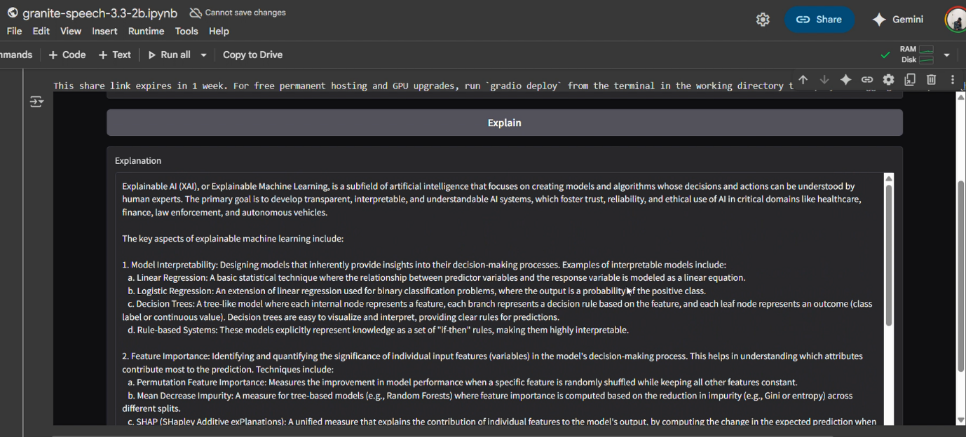

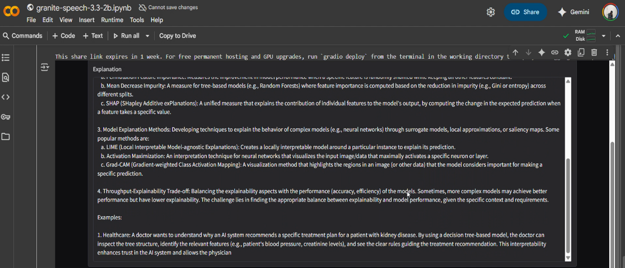

**12. Known Issues**

* Initial model training may require large datasets.
* Some quizzes may need manual review for accuracy.

**13. Future Enhancements**

* Multilingual tutoring support
* Integration with popular LMS (Moodle, Google Classroom)
* Real-time voice tutoring and speech-to-text support.